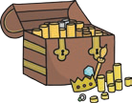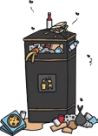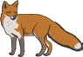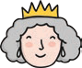



**Phonics Activity Mat 1**

**visit twinkl.com**

Write a word that contains **ure**.

Add the sound buttons to these words.

spears

thing

clouds

Circle all of the words that contain the **ee** digraph.

speak

coins

meet

fair

street

hard

night

free

Read these words to a friend.

chatter

landpot

spray

phote

leap

frung

sheep

plig

chin

hoff

Write the missing sounds in these words.

ph n

h m

l k

b d

cr on

spr t

b ger

ink

een

fo

Write the real words next to the chest and the nonsense words next to the bin.

dush

blank

moin

wess

haunt

chomp

lith

fight