Ajay has just arrived at Joe’s house before school. Joe’s mother is the warden who looks after the local park.
The Park
Ajay was just about to tuck into his tea and toast dripping in sour rhubarb jam when there was a loud clatter from the letterbox as an important-looking brown envelope landed on the mat. ‘Bit early for the post isn’t it?’ Mum said. ‘Ooh, it says Special Delivery.’ Mum opened it, and unfolded the letter.  Joe knew instantly that something was wrong. He could see it on Mum’s face. ‘What is it, Mum?’ Joe asked.  ‘Yeah, Mrs P, what’s happened?’ Ajay asked too.  ‘It’s the park… they’ve shut it down.’  For a second no one said a word. Joe and Ajay looked at each other, then back at Joe’s mum. Her face was pale, her jaw dropped open. She stared at the letter, her eyes watery and ready to spill over with tears.  ‘Shut the park!’ Joe said furiously. ‘They can’t do that, it’s… it’s the park!!’  ‘Yeah, everyone loves that place!’ Ajay joined in.  ‘You boys best get to school, or you’ll be late,’ said Mum, her voice all shaky.  ‘But what about…?’ Joe started to say.  ‘You leave that to me, I don’t want you worrying.’ Mum tried to smile, but it didn’t reach her eyes. If she was trying to reassure Joe, it wasn’t working. He knew his mum needed that job – how else was she supposed to put sweet-and-sour spaghetti on the table?  ‘Don’t worry, Mum, I’ll… I’ll think of something.’  Joe’s mum just nodded, turning away to wipe her eyes. | 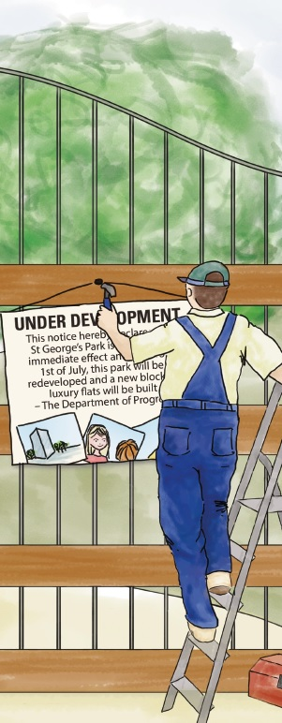
Joe and Ajay grabbed their bags and reluctantly headed out of the door. Neither of them said anything for what seemed like ages.
‘You all right, man?’ Ajay asked, breaking the silence.
‘I don’t know… I can’t believe they’ve closed the park. I mean, why?!’ Joe said in disbelief.
‘Dunno,’ Ajay shrugged. ‘But I know a man who might,’ he said, pointing down the road.
As they turned the corner at the top of Joe’s street they saw a man in the distance. He had a ladder and toolbox and was busy hammering a sign into the park gates. This made Joe’s blood boil. If Mum had been there she would have given him what for – no one hammers anything into anything without her say-so first.
‘Oi!’ Ajay yelled, ‘what are you doing?’
Joe read the sign: ‘Under development.’
‘What’s going on?’ Joe asked. ‘Why have you closed the park?’
The man stopped what he was doing and shrugged. ‘They don’t tell me anything, I’m just the bloke who hammers things.’
Joe read the rest of the sign:
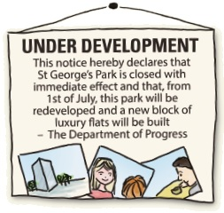
Underneath the notice was a drawing of a posh building, tall and made of glass. It had pictures of smiling people chatting and drinking coffee outside. Joe and Ajay looked through the park gates and could already see diggers moving in, ready to tear the playground apart.
‘This can’t be happening,’ Joe muttered, blinking back the tears. This was the place where he and Ajay hung out. Where they used to plot how they were going to become mega rich, and plan what to do if the world got taken over by zombies. This was the place where Joe and Ajay used to play football – or rather where Ajay would kick the ball and Joe would try to get out of the way of it before it hit him in the face. And now it was going to be turned into flats! Why wasn’t anyone stopping this?

1. What is Ajay doing when the post arrives?
______________________________________________________________
1 mark
2. How does Joe know that the letter contains bad news before his mum tells him what it says?
______________________________________________________________
1 mark
3. What does the letter in the brown envelope tell Joe’s mother?
______________________________________________________________
1 mark
4. Look at page 1.
Find and copy one word which shows that Joe is angry.
____________________________________
1 mark
5. Look at page 1.
In Ajay’s opinion, how do people feel about the park?
______________________________________________________________
1 mark
6. Look at the paragraph beginning: ‘You boys best get to school...’ to the end of page 1.
‘But what about...?’ Joe started to say.
Which words would best complete Joe’s question?

Tick one.
your breakfast
our games
your job
our homework
1 mark

7. What is Joe’s mother thinking after she reads the letter?
Tick one thought.
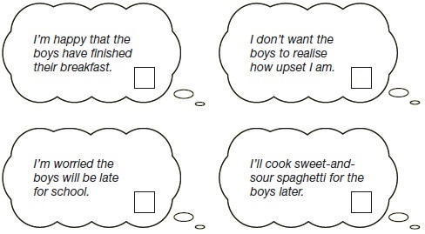
1 mark
8. If she was trying to reassure Joe, it wasn’t working.
What does reassure mean in this sentence?
______________________________________________________________
1 mark
9. Look at the paragraph at the top of page 2.
Find and copy one word that shows the boys do not want to leave the house.
____________________________________
1 mark
10. Oi!’ Ajay yelled, ‘what are you doing?’
Joe read the sign: ‘Under development.’
‘What’s going on?’ Joe asked. ‘Why have you closed the park?’
Joe and Ajay react differently to seeing the man hammering in the sign.
How does Joe react?

Tick one.
He is calmer.
He is ruder.
He is less interested.
He is less worried.
1 mark
11. Look at the sign from the story.
Who has produced the sign?
______________________________________________________________
1 mark
12. Look at the paragraph beginning: Underneath the notice was a… to the end of page 2.
What is happening inside the park straight after Joe and Ajay have read the sign?
______________________________________________________________
1 mark
13. Using information from the text, tick one box in each row to show whether each statement is true or false.

 | True | False
The park has been looked after by a park warden.
The park is going to be replaced with a shopping centre.
Building work in the park will start at the end of July.
The warden had two weeks’ notice of the park’s closure.
2 marks

