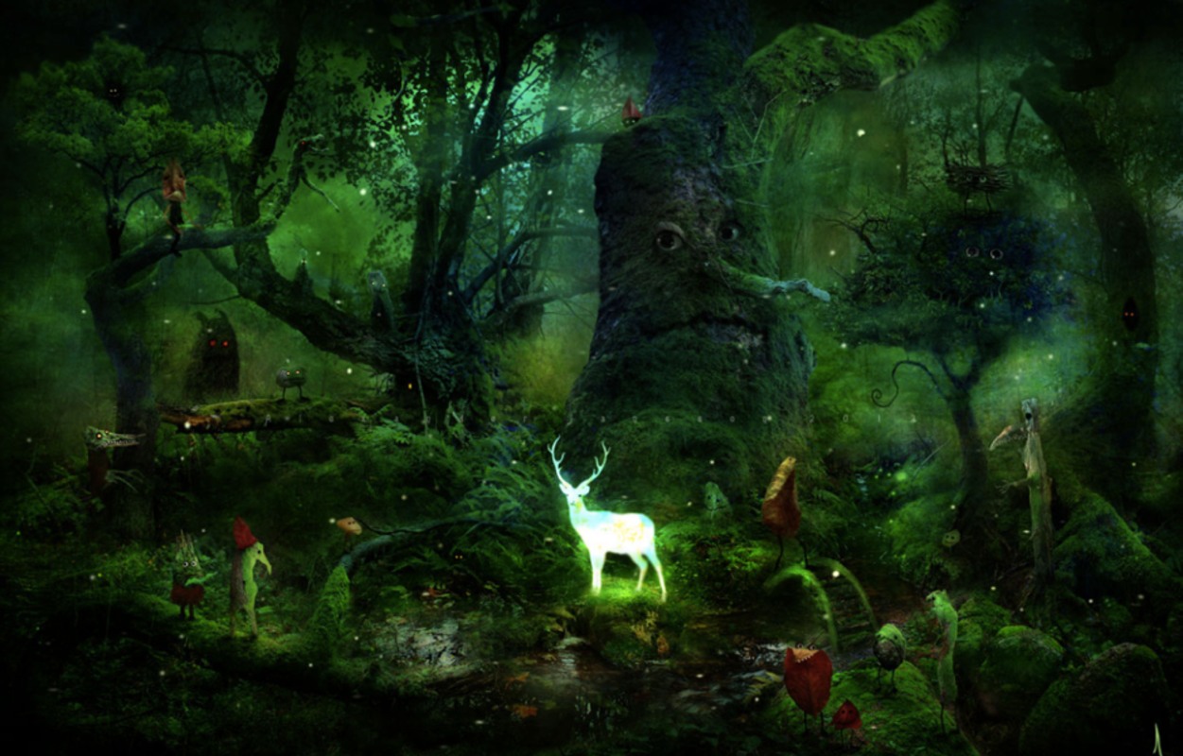

Story starter:
Eyes. Wherever you went in Watchwood Forest there were eyes. It was home to the most beautiful and mysterious creatures in the entire realm, yet very few human eyes had ever seen it.
One day, at the time of year where it stays sunny and warm well into the evening, a little girl called Rose decided she would explore Watchwood Forest. Rose had been told by her parents and by numerous other bossy grown-ups that she was never to go into the Forest.
Now, to you and me (as the kind of people that always follow the rules), it might seem a little careless and a bit reckless and maybe even a bit foolish for Rose to find herself in such a place, especially after been told such a thing! However, Rose was not that sort of girl. In her mind, rules were there to be broken…

