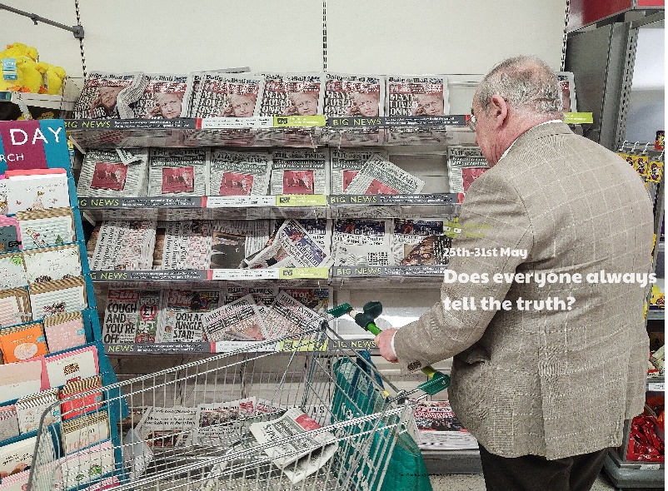

**Use this sheet to let a grown-up write down all your thoughts on this week’s story.**

* Do you have a newsagent near you? What else can you buy from a newsagent?
* How do the grown-ups in your house find out about the news?
* How would you feel if you heard a news story and then found out it wasn’t true?
* Who are the people in your life that you can trust to tell you the truth?