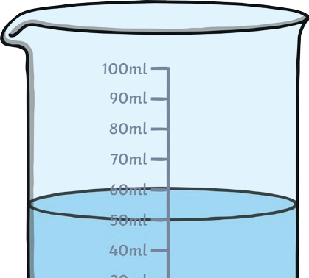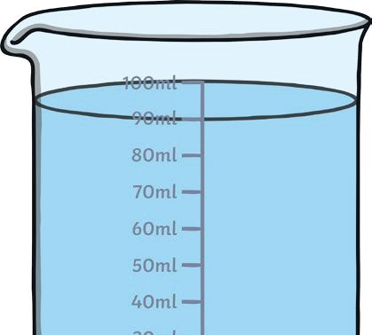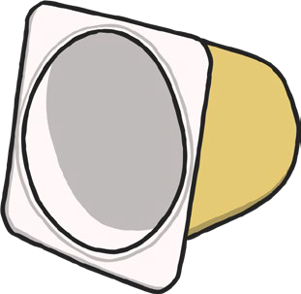
CapacityChallenge Cards
1. Choose 3 containers. Take a cup or a yoghurt pot and find out how many scoops it takes to fill each container. Line your containers
up in order from smallest to largest.
twinkl.co.uk

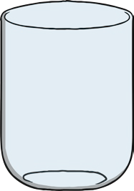

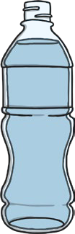
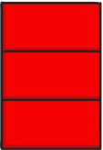
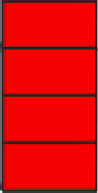
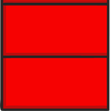
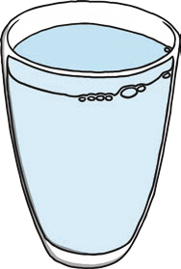
2. I fill my container with 5 cups of water. My friend’s container takes 3 more cups to fill. How many cups does it take to fill my
friend’s container?
twinkl.co.uk
3. I fill some containers. I make a tower of bricks, one brick for each cupful of water I use. Which is the largest container? Which is the second largest? Which is the smallest? Try this with
a friend.
twinkl.co.uk
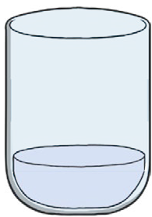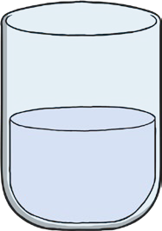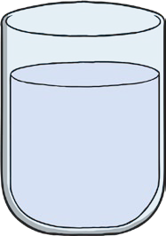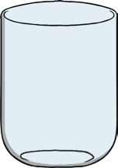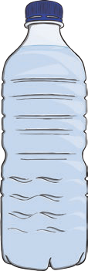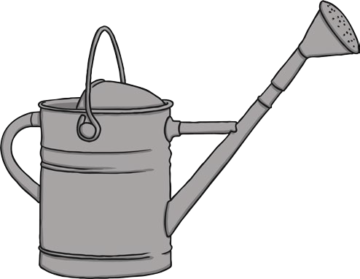
4. I fill some containers. I make a tower of bricks, one brick for each cupful of water I use. Which tower should go next to which container? Try
this with a friend.
twinkl.co.uk
5. Choose some different containers. Does the tallest
container always hold the most water? Why? Why not?
twinkl.co.uk

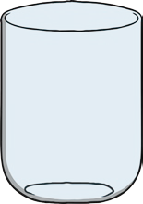
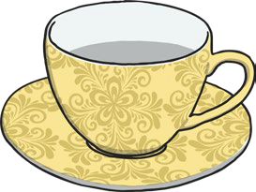
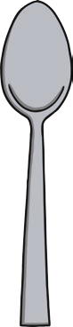
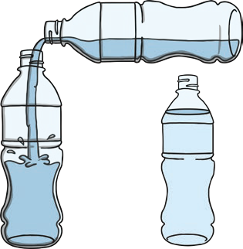
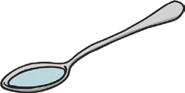
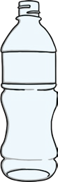
6. Have a race with a friend to fill a container each. One person use a spoon to fill, and the other use a cup. Who is the winner? Is this fair? Why?
Why not?
twinkl.co.uk
7. Leo and Larry are racing to fill their containers. Who will be the winner? What would you do to
make the race fairer?
twinkl.co.uk
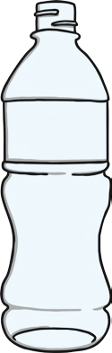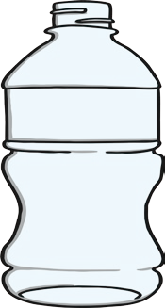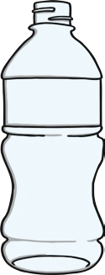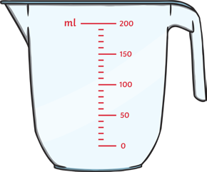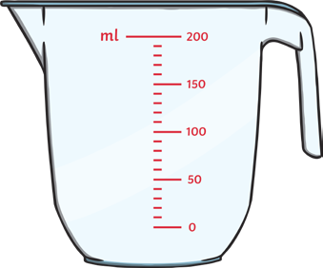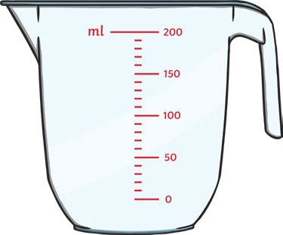
8. Which of the bottles looks the largest? Which is the largest? Find some bottles with measures on.
Can you trick your friends?
150ml
100ml
200ml
twinkl.co.uk
9. Which of the jugs is the smallest? Can you
findsomedifferentjugsandbottleswith measurements on?
twinkl.co.uk

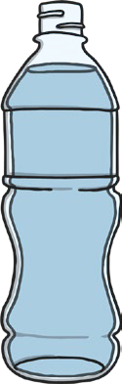
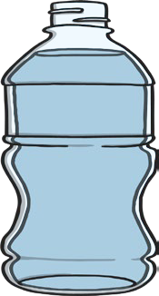
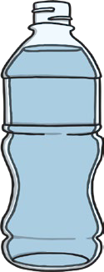
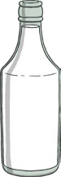
10. All the bottles contain the same amount of water.
Do you agree? Why? Why not?
twinkl.co.uk
11. I buy 10 litres of milk. I use half of it. How many
litres do I have left?
twinkl.co.uk
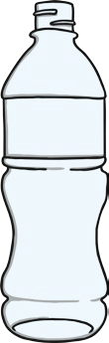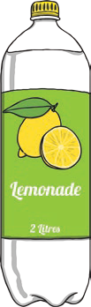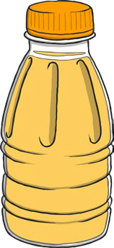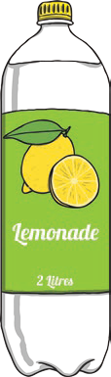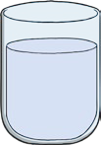
12. Find 3 different shaped bottles. When you fill them to the same height with water, do they contain the same amount? Explain why or
why not.
twinkl.co.uk
13. I fill my bottle with 7 cups of water, my
friend’s takes 2 fewer. How many cups does it take to fill my friend’s bottle?
twinkl.co.uk

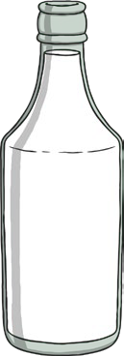
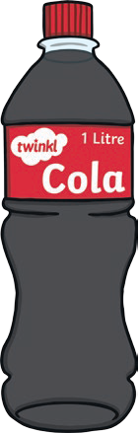
14. I buy 12 litres of milk in 2 litre bottles. How many
bottles do I buy?
twinkl.co.uk
15. Cola comes in 2l bottles. I buy 7 bottles
for my party, how many litres is that?
twinkl.co.uk
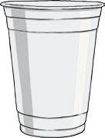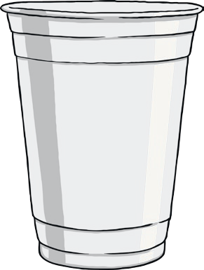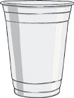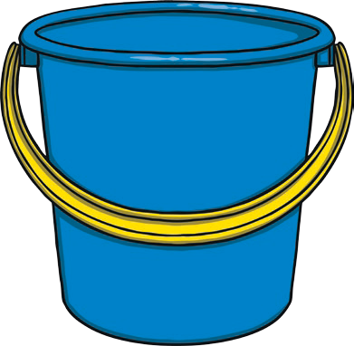
16. I can fit 100ml of water in a cup. If it takes 7 cups
to fill my bottle, how big is my bottle?
100ml
twinkl.co.uk
17. My bucket fits 800ml of water. If it has taken 10
cups to fill it, how big is my cup?
800ml
twinkl.co.uk

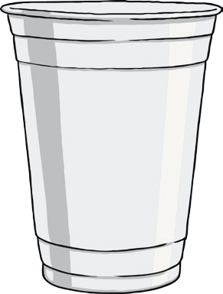
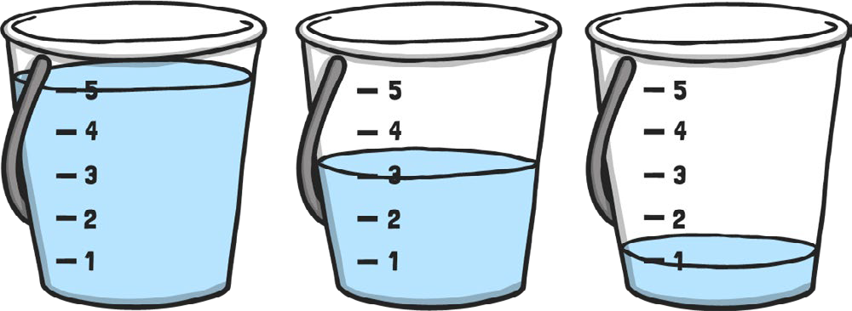
18. Can you fill some cups so one is half full, one
is less than half full and the other is full?
twinkl.co.uk
19. Ellie is on the beach, she is filling buckets from
the sea. How would you describe her buckets?
twinkl.co.uk
20. I have 4 buckets. One bucket is nearly empty, another is full, one is more than half full and the last one is a quarter full. Can you order my
buckets from emptiest to fullest?
almost empty
quarter full
more than half full
full
twinkl.co.uk

