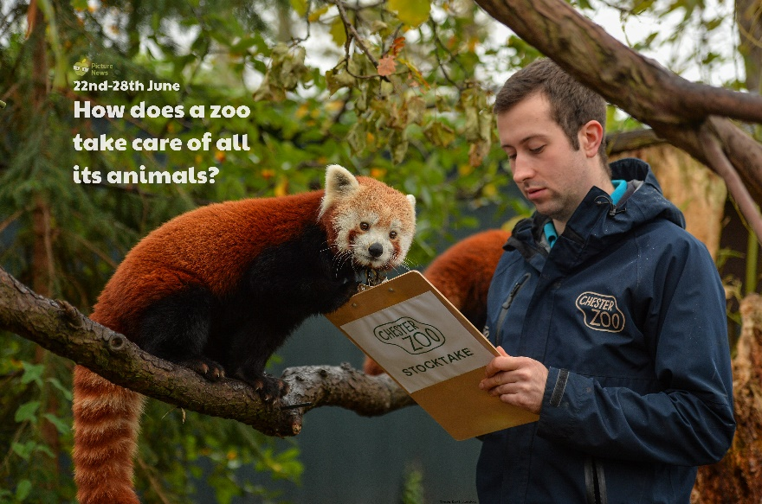

**Use this sheet to let a grown-up write down all your thoughts on this week’s story.**

* What can you see? Where do you think this photo has been taken?
* What is a zoo? What animals do you think you might find there?
* Which animals would you enjoy seeing? Are there any you wouldn’t like to see? Why not?
* What jobs do you think a zookeeper needs to do?
* Which of the jobs would you like to do?