June 2020
Dear Parents,
We’re really looking forward to teaching your child in September. We hope they are also very excited too!
We would be grateful if you could let us know a little more about your child prior to them starting. We’d like to know:
- What things does your child currently like?
- Are there any things that your child dislikes?
- What activities do they particularly enjoy?
- How do you think they will be on their first day? If they were to become upset, how do you think they would be best comforted?
Please also let us know if your child has any personal care needs, for example: requires help getting on/off toilet, needs support taking shoes and coat on/off.
Any additional information you choose to share is really useful as it helps us forge a good relationship with your child right from the start. It also shows them that we are working together - as they are always very curious to know how we already know so much about them!
We would be very grateful if you can send us this information via this email address: foundation.stage@tsp.sefton.school prior to their first day, attaching a recent photograph of them also. Please kindly note that we do not reply from this email account.
Before your child joins us in Nursery, we will be arranging to meet you and your child via Zoom. Further information will follow in due course regarding this.
We look forward to receiving your emails about your child.

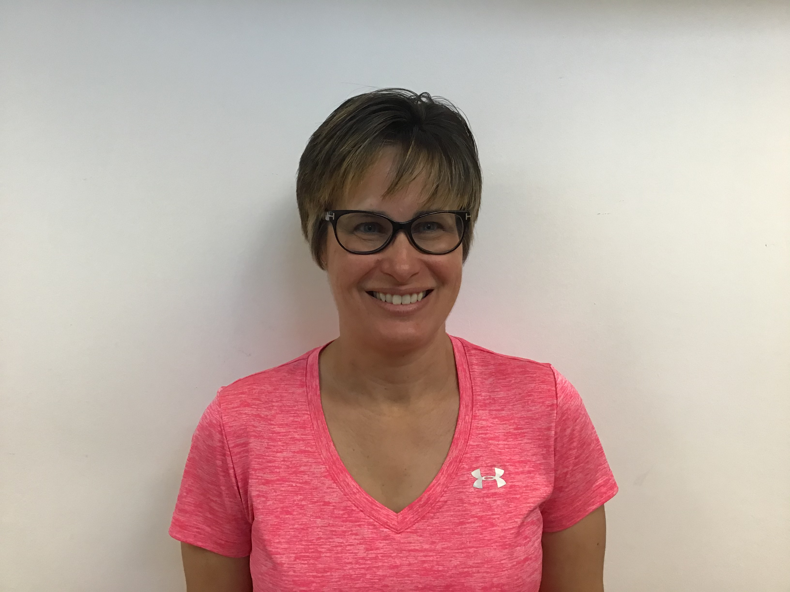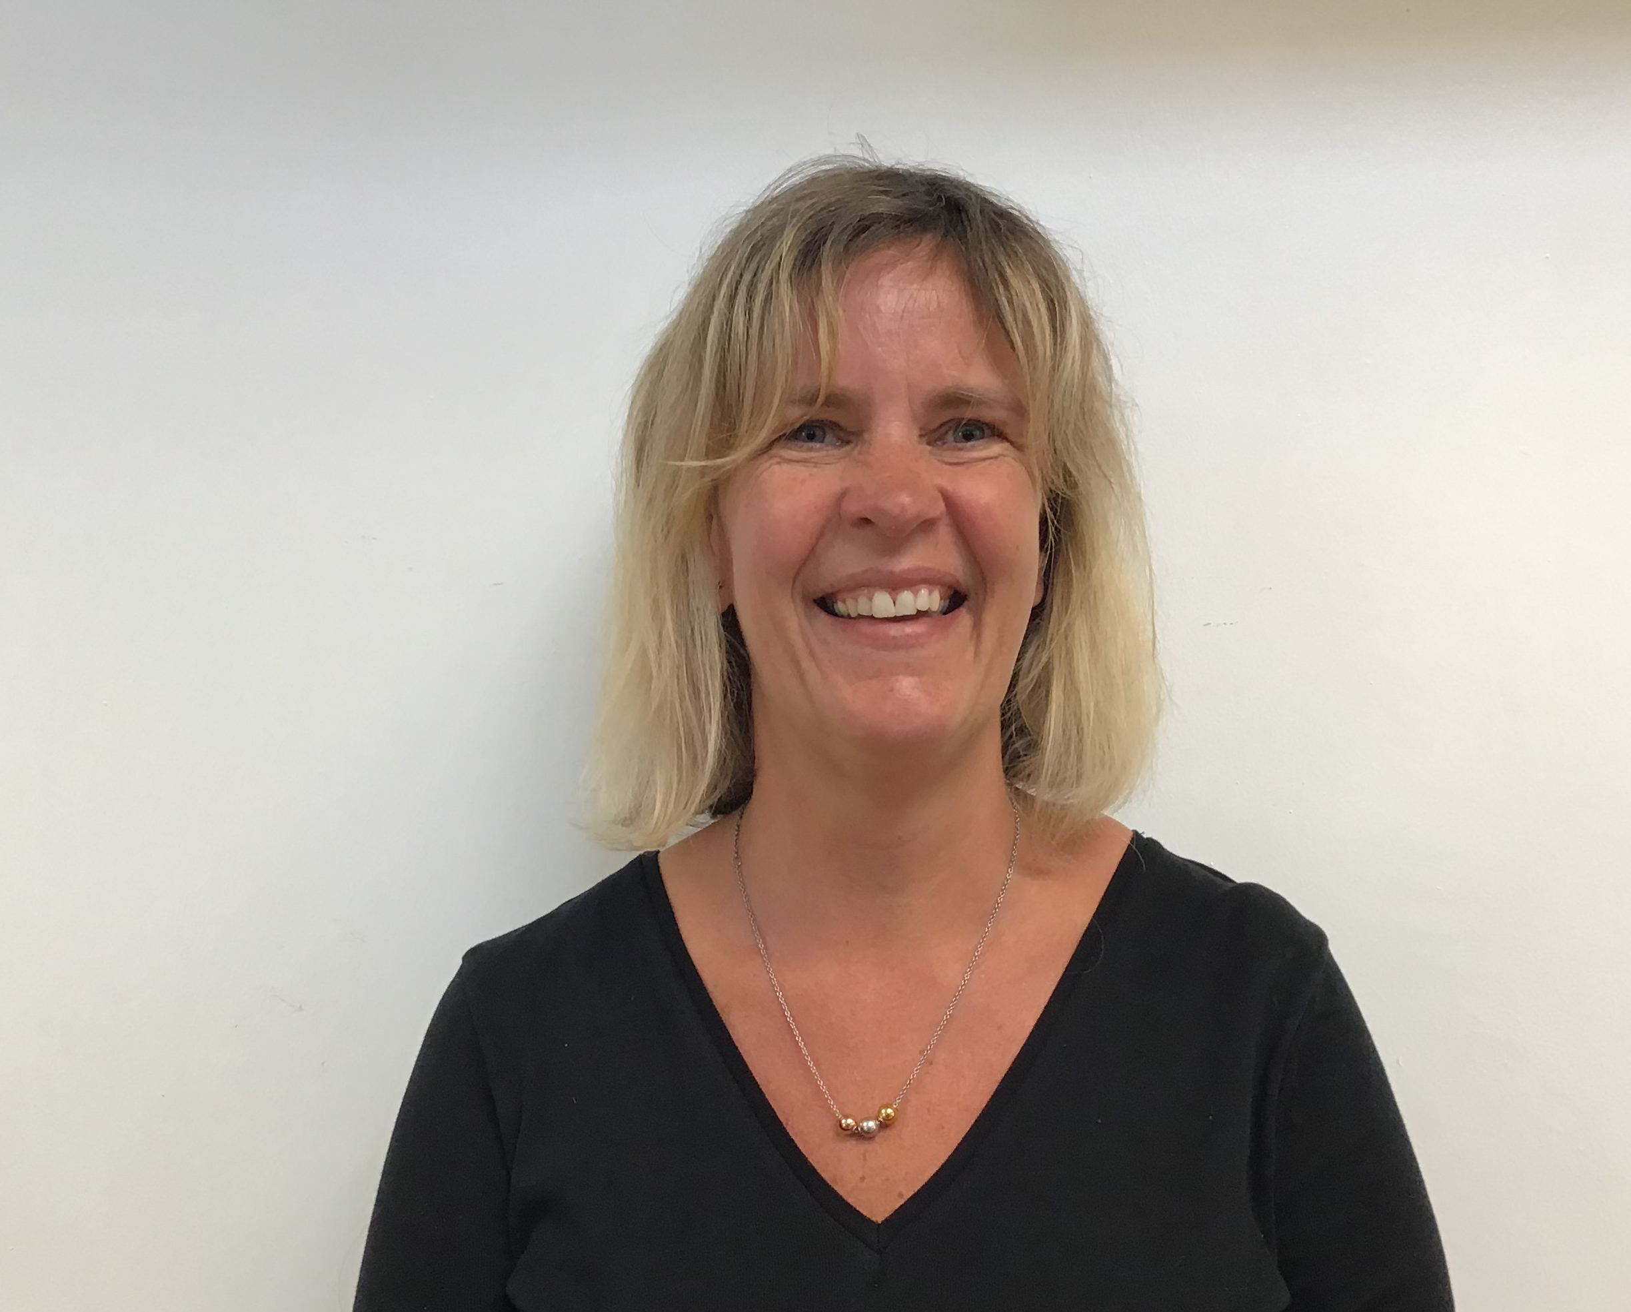
Mrs Bevin Mrs Molloy
Class Teacher Class Teacher

