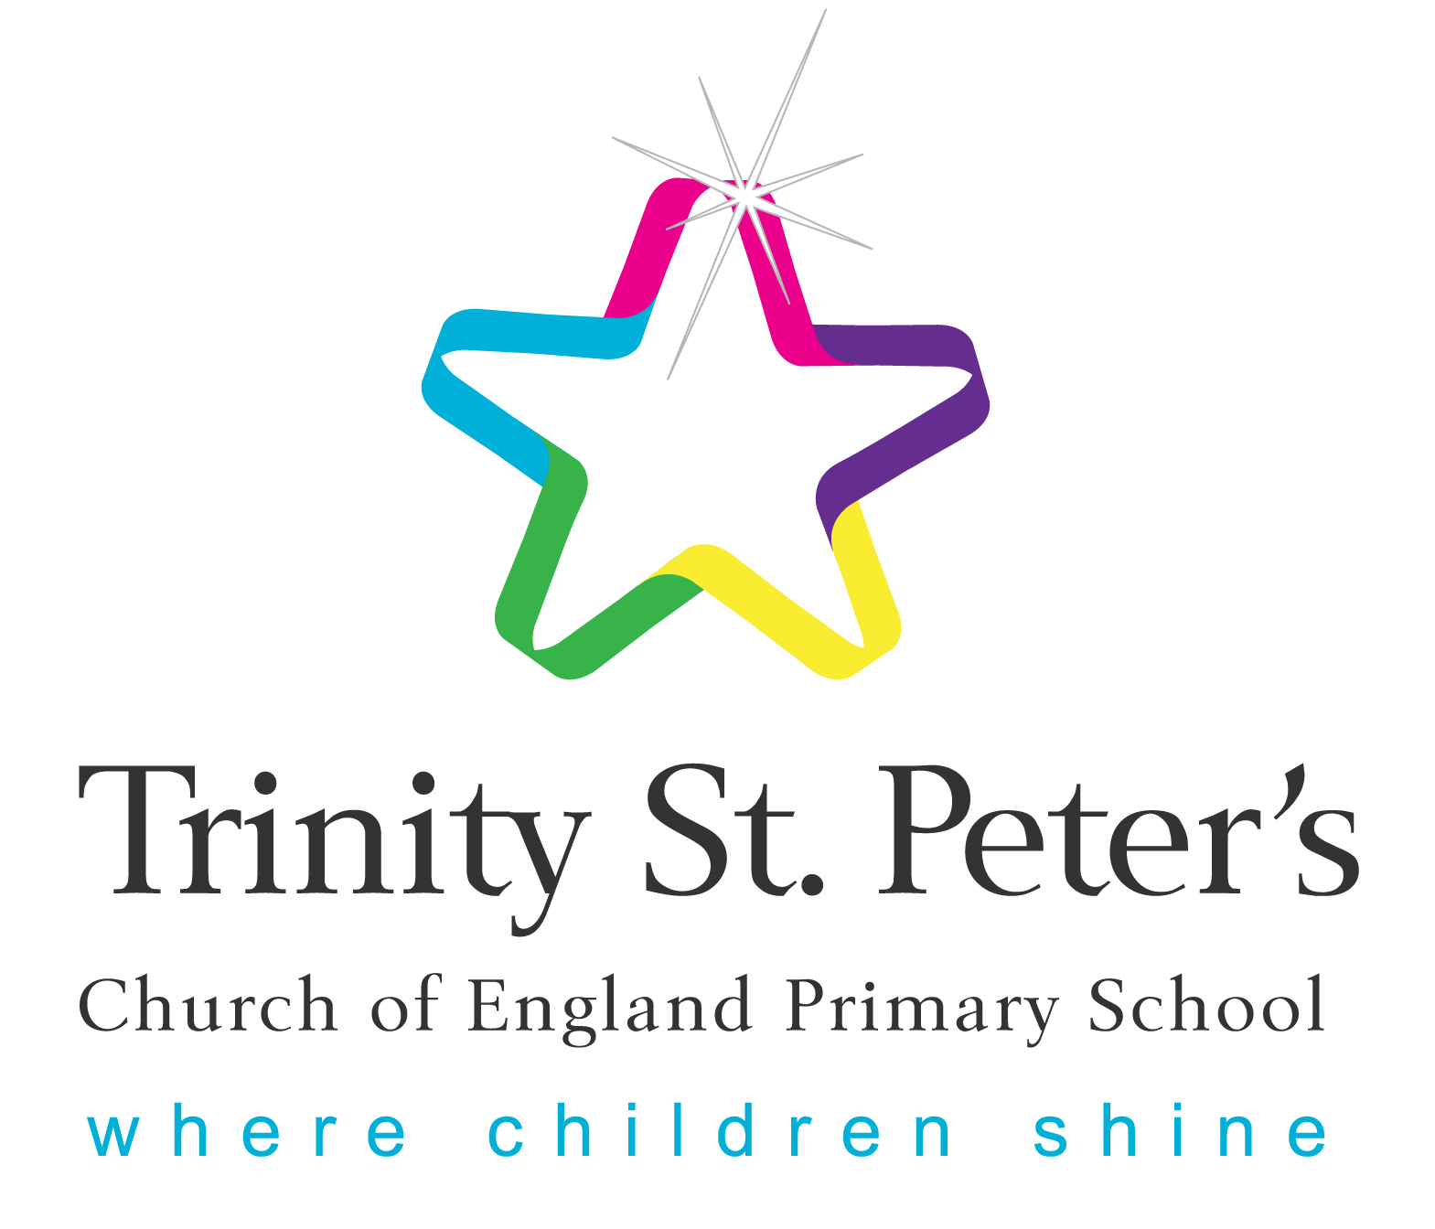

Trinity St. Peter’s Church of England Primary School

EARLY YEARS FOUNDATION STAGE (EYFS)

PERMISSION FROM PARENTS/CARERS FOR OBSERVATIONS.

Child’s Name:

Children develop and learn in different ways and at different rates. Every child deserves the best possible start in life and the support that enables them to fulfil their potential. Children develop quickly in the early years and a child’s experiences between birth and age five have a major impact on their future life chances. A secure, safe and happy childhood is important in its own right. Good parenting and high quality early learning together provide the foundation children need to make the most of their abilities and talents as they grow up.

The Early Years Foundation Stage (EYFS) sets the standards that all early years providers must meet to ensure that children learn and develop well and are kept healthy and safe. It promotes teaching and learning to ensure children’s “school readiness” and gives children the broad range of knowledge and skills that provide the right foundation for good future progress through school and life.

We aim to ensure that every child’s learning and care is tailored to meet their individual needs. Our team will seek to engage and support parent/carers in guiding their child’s development at home. They will also help families engage with more specialist support if appropriate.

In order for us to meet the requirements of the EYFS 2017, we would be grateful for your permission to observe and assess your child’s achievements and share any relevant information with each other or any other childcare providers/childminders that look after your child. Information will be stored confidentially and we will always seek verbal consent.

Parents/Carers will be given free access to developmental records about their child. However, a written request must be made for personal files on the children and School will take into account data protection rules when disclosing records that refer to third parties.

PERMISSION FOR OBSERVATION/ASSESSMENT
I/We give permission for my child to be observed and assessed.

YES NO

PERMISSION FOR PHOTOGRAPHIC EVIDENCE
I/We give permission for my child to be photographed for EYFS evidence.

YES NO

OTHER CHILDCARE PROVIDERS

Details of any other childcare providers / childminders that look after your child.

Name/Contact: Name/Contact:

Details of childcare provided: Details of childcare provided:

Tel No.: Day: Tel No.: Day:
Evening: Evening:
Mobile: Mobile:

TWO YEAR OLD CHECK
Was a two year old progress check completed?

YES NO

If so, what was discussed?

PERMISSION TO CHANGE MY CHILD’S CLOTHING.
During your child’s time at School there may be occasions when we need to change your child’s clothing eg. wet clothes from water play, spilt paint/drinks, toilet accidents etc.
On rare occasions a child may soil themselves and it may be necessary to help them clean themselves using the shower facilities.
For Child Protection & safeguarding reasons we require your written permission to carry out the above.
If you would prefer us not to clean your child using the shower facilities, we would then call for someone to come to school to clean your child.
If we do change your child’s clothing or help your child clean themselves, we will keep you informed.
Please tick as appropriate:

I/we give permission for my child’s clothing to be changed when necessary.
YES NO

I/we give permission for my child to be cleaned using the shower facilities.
YES NO

Parent/Carer Name:

Parent/Carer Signature:

Date:

