**Doubles to 20**

**Ladybird Doubles**

Write the number sentence for each ladybird double.



# 1+1=

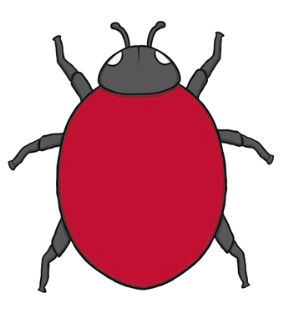

2+2=



3+3=

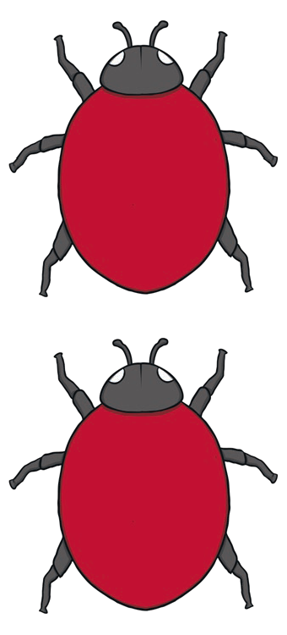

4+4=

5+5=

**Doubles to 20**

**Ladybird Doubles**

Write the number sentence for each ladybird double.



# 6+6=



7+7=





8+8=





9+9=



10+10=

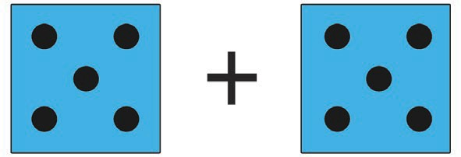

**Doubles to 20**

1+1=

Write the number sentence for each dice double.

**Dice Doubles**

2+2=

 3+3=

# 4+4=

5+5=

## Dice Doubles

**Doubles to 20**

Write the number sentence for each dice double.



# 6+6=



7+7=



8+8=



9+9=

10+10=



**Doubles to 20**

**Butterfly Doubles**

Write the number sentence for each butterfly double.

1+1=

 2+2=

 3+3=

# 4+4=

5+5=

**Doubles to 20**

Write the number sentence for each butterfly double.

**Butterfly Doubles**



6+6=



7+7=



8+8=



9+9=



10+10=



**Doubles to 20**

**Number Shape Doubles**

Write the number sentence for each number shape double.

 +  1+1=

 +  2+2=

 +  3+3=

# + 4+4=

5+5=

+



**Doubles to 20**

10+10=

Write the number sentence for each number shape double.

**Number Shape Doubles**

+ 6+6=

 +  7+7=

 +  8+8=

# + 9+9=

+