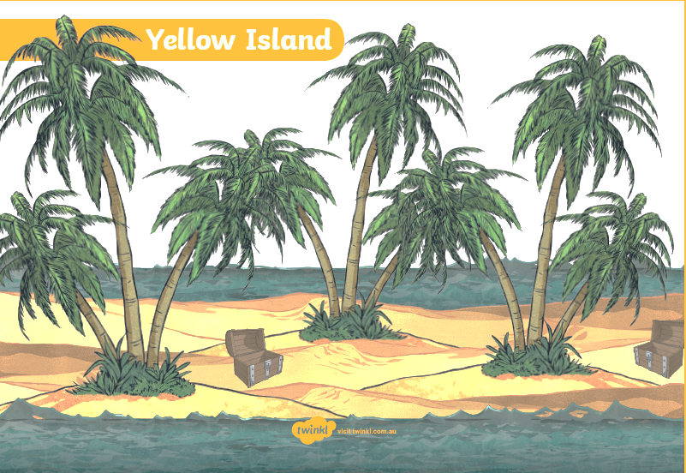

Desert Island

5 things I would take with me to a desert island.

5._________________________

4._________________________

3._________________________

2._________________________

1._________________________