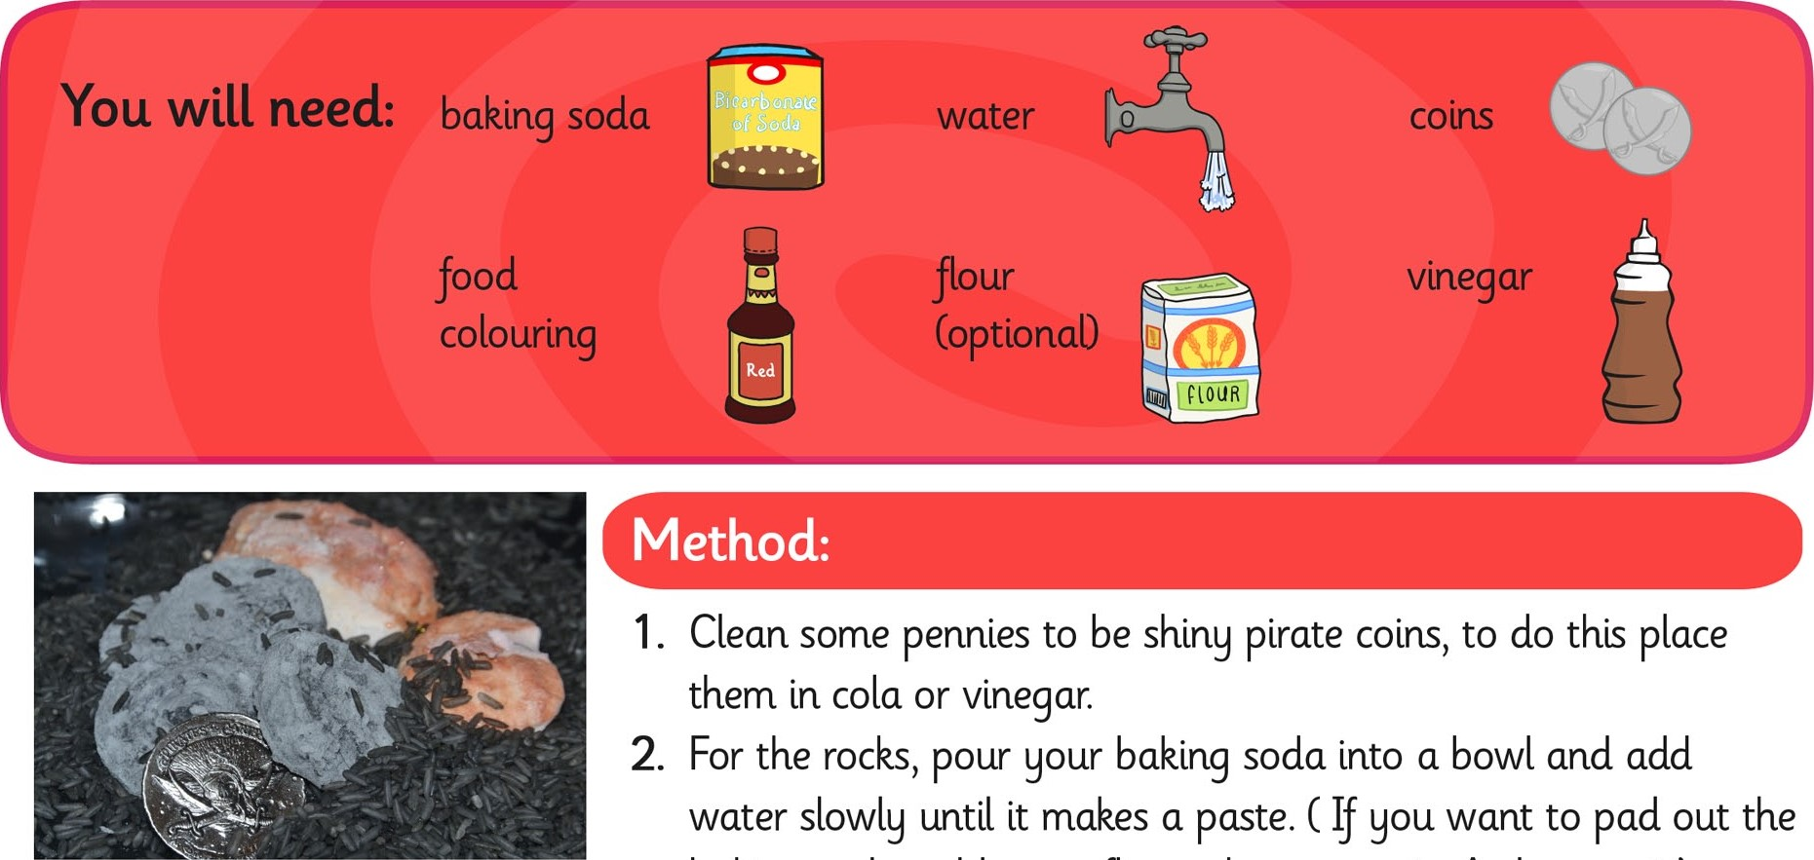

1. Clean some pennies to be shiny pirate coins, to do this place them in coke cola or vinegar.
2. For the rocks, pour your baking soda into a bowl and add water slowly until it makes a paste. (If you want to pad out the baking soda, add some flour when you mix. As long as it’s not more than half and half you should still get a good reaction).
3. Add a couple of drops of food colouring and mix well.
4. Either mould with your hands or use cake moulds to create shapes, press a coin into each.
5. Leave in the fridge overnight.
6. Use a dropper to drop vinegar onto your pirate rocks.