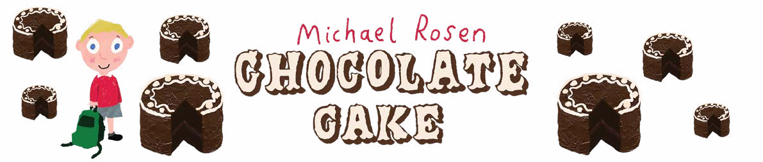

My favourite food poem
Write a poem about your favourite food using some of the writing methods that you looked at earlier. You can use the writing frame and word bank below to help you.

My favourite food in the entire world is ............................................

It looks ...............................................................................................

It smells ...............................................................................................

When I take a bite it makes a sound.

It feels ............................................................................ in my mouth.

WORD BANK
shiny
dull
soft
hard

delicious
sweet
salty
hot

cold
bitter
creamy
crunchy

gooey
yum
gobble
ahhh

Inspiring you to share stories

