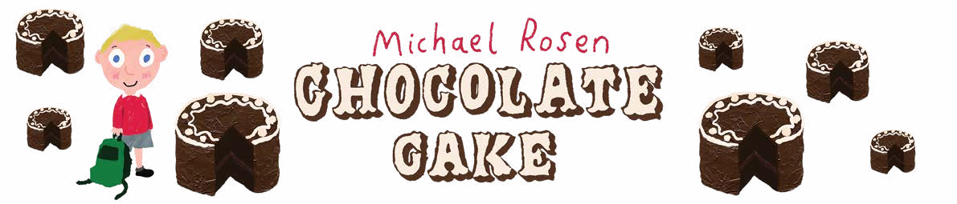

Writing a poem
Can you find all the writing methods that the author has used in this part of the poem?

Circle all the onomatopoeic words in red, the alliteration in blue, the descriptive adjectives in green and the metaphor in yellow.

Oh the icing on top and the icing in the middle ohhhhhh oooo mmmmmm.

But now
I can’t stop myself Knife -
I just take any old slice at it and I’ve got this great big chunk
and I’m cramming it in what a greedy pig but it’s so nice,

and there’s another
and another and I’m squealing and I’m smacking my lips and I’m stuffing myself with it
and before I know I’ve eaten the lot.
The whole lot.

© Author: Michael Rosen

Inspiring you to share

